**Machine Learning (ICP # 1)**

**Name: Preksha Reddy**

**700#: 700759508**

## [https://colab.research.google.com/drive/1L3gKD0EMyKSSojWd3HzPXbcFTuZAeoSt#scrollTo=1c1d2aZ3cwWf](https://colab.research.google.com/drive/1L3gKD0EMyKSSojWd3HzPXbcFTuZAeoSt%23scrollTo=1c1d2aZ3cwWf)

Question 1:

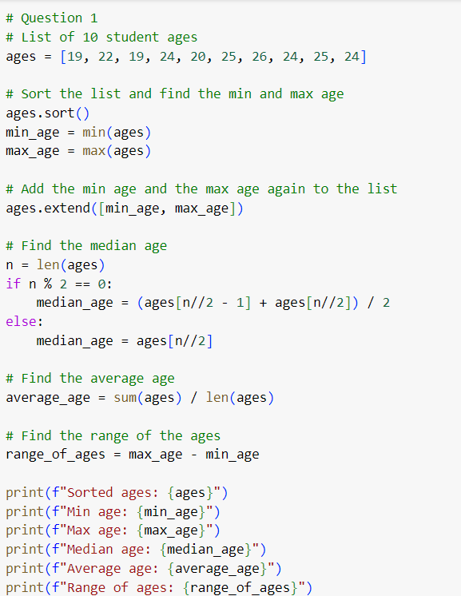

Output:

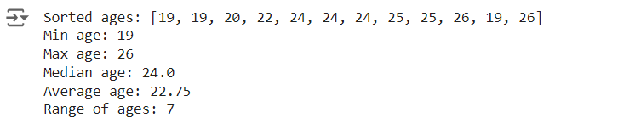

This code determines the lowest and maximum ages by first sorting the list of ages, and then adding the minimum and maximum ages back to the list. The middle value of the sorted list is found to determine the median age. The median is the average of the two middle values in a list with an even number of members. By adding together all the ages and dividing by the total number of ages, one may determine the average age. Lastly, by deducting the minimum age from the maximum age, the range of ages is determined.

Question 2:

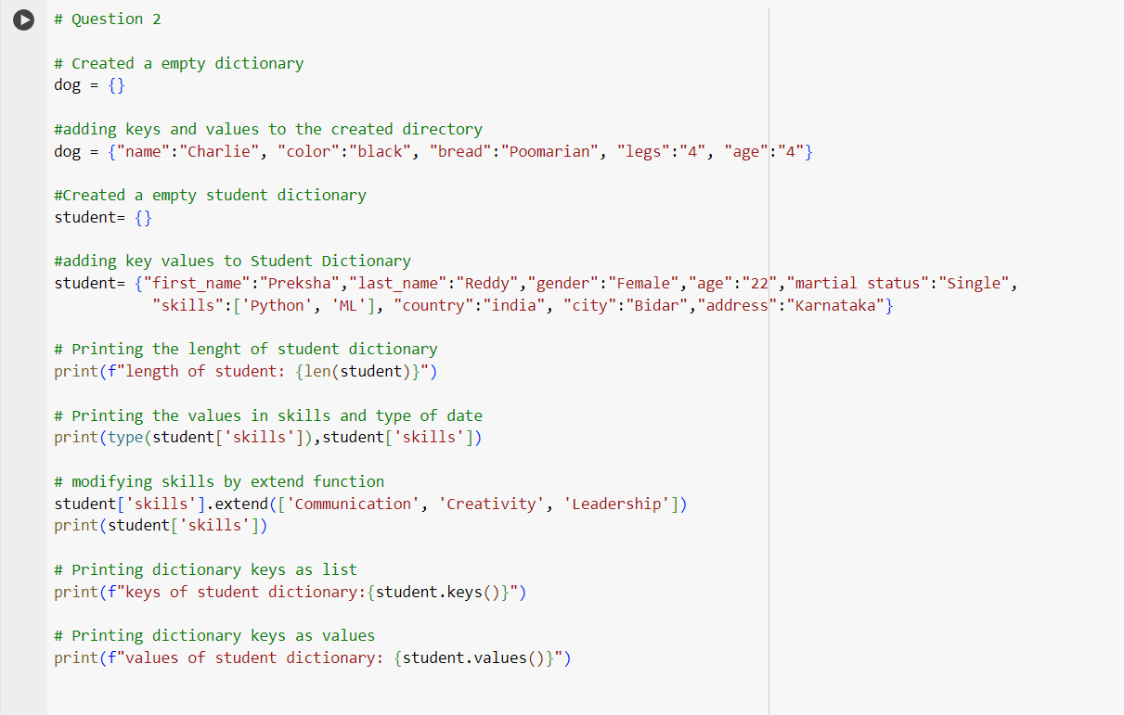

Output:



An empty dictionary dog is created and the keys and values filled with information about a dog are added. In a similar manner, empty student dictionary is generated and loaded with data on a student. The kind and contents of the skills list are printed after the length of the student dictionary. Then, more skills are added to the list of abilities. In order to show how to access and display dictionary data, the student dictionary's keys and values are written at the end.

Question 3:

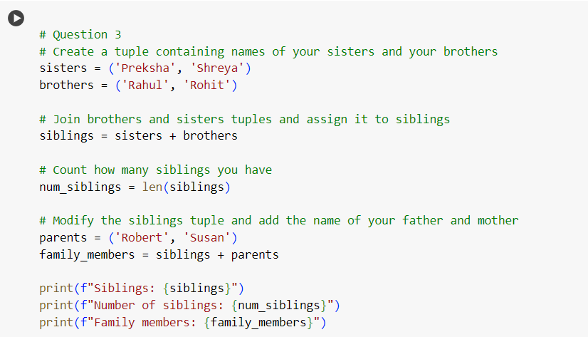

Output:

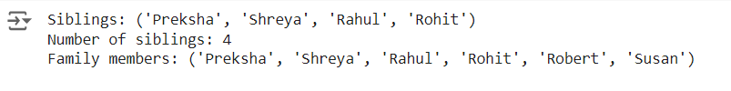

The code generates tuples for brothers and sisters, then merges them to produce a new tuple including all siblings. It determines the entire count of siblings. Next, it builds a tuple for each parent and joins it with the tuple for each sibling to generate a new tuple for family members. It produces a new tuple to include the parents because tuples are permanent. Lastly, the number of siblings and all of the family members are printed.

Question 4:

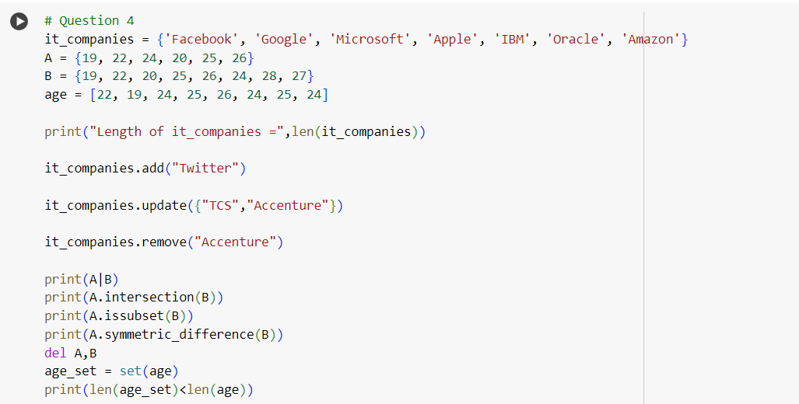

Output:

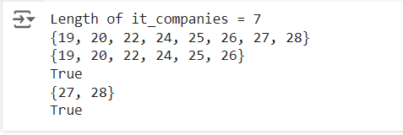

The code manages sets of companies and ages, finding lengths, adding elements, performing set operations (union, intersection, subset check, symmetric difference), removing duplicates, and checking for duplicates in ages.

Question 5:

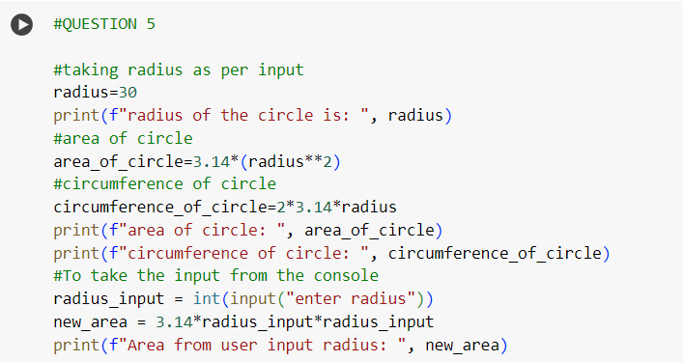

Output:

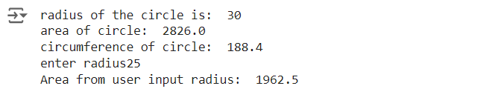

The area and circumference of a circle are calculated in this code. It determines the area and circumference first, then sets a radius value. Then, it requests that you enter a radius value, using the information you provide to compute the area.

Question 6:

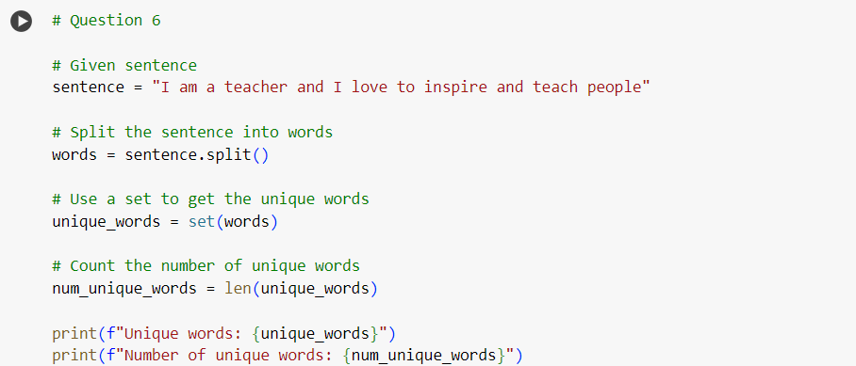

Output:



In this code each unique word in a sentence is counted. It breaks the statement up into words, then eliminates duplicates using a set. The number of unique words is then determined by counting the number of words in the set.

Question 7:

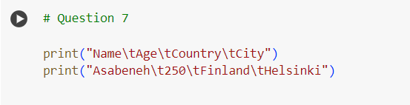

Output:



This code generates a basic table to show a person's details. Using tab characters (\t) to create space between the labels for "Name," "Age," "Country," and "City," the first line functions as a table header and the second line filled with person's actual data filled in the database.

Question 8:

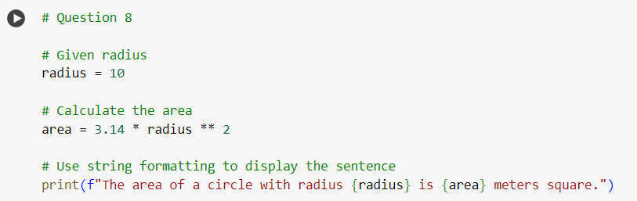

Output:



In this code the area of a circle is determined. After setting the radius to 10, the area is calculated using the formula area = 3.14 * radius**2. Lastly, it uses f-strings formatted to display the sentence.

Question 9:

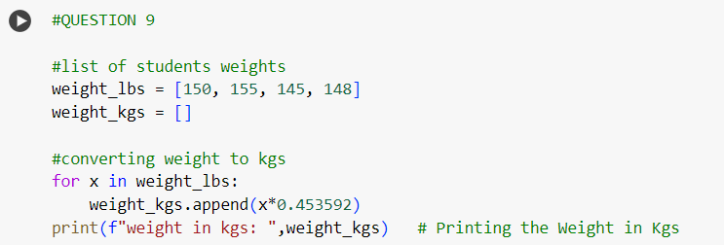

Output:



A list of weights is converted from pounds (lbs) to kilograms (kgs). It features an empty list for kilograms and a list of weights in pounds. It goes over each weight in pounds, multiplies it by a certain amount to convert it to kilograms, and then adds the resultant weight to the list of kilograms. The list of weights in kilos is displayed at the end.